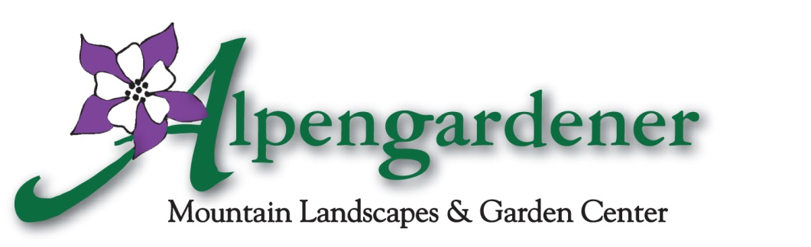

Container Planting Information Form

In order to serve you better, please provide us with as much information as possible so that your annual plantings custom fit you and your home.

Name_____________________________________________________________________
Contact/Property Manager (if other than customer)_________________________________
Local Address______________________________________________________________
Billing Address _____________________________________________________________
Best contact phone number____________________________________________________
Number of containers________________________________________________________
Where are they stored______________________________________________
Number of containers in the shade _____________ in the sun ______________
Number of Baskets
Large Moss____ Small Moss____ Plastic_____Coconut Fiber______
Container and/or Basket Budget____________________
Color/plant preferences_______________________________________________________
__________________________________________________________________________

Any specific likes ___________________________________________________________

Any specific dislikes_________________________________________________________

Any special requests_________________________________________________________

Estimated Arrival Date ______________________

Date you would like your pots or baskets delivered_________________________________

Any special events scheduled_____________________________________

Please feel free to contact Ellen at Alpengardener by phone or email; (970) 349-0252, garden@alpengardener.com with any other information, or send pictures of previous plantings that you enjoyed.

Thanks!

Ellen
Chief Potter

